<<20130501>> Archived distributions can be retrieved at; <http://tinyurl.com/azg3eyl <http://tinyurl.com/azg3eyl> >. This archive includes a html version of this list distribution and its MS/WORD version with its filename as “year-month-date.doc.” You can also access all of its attachments, if any.
Synopsis
of
Global Early Warning System (GEWS) and Global University System (GUS)
Takeshi Utsumi, Ph.D.
Chairman
GLObal Systems Analysis and Simulation Association in the U.S.A. (GLOSAS/USA)
(May 1, 2013)
The highly interconnected and coupled nature of energy, healthcare, food security, natural resource management and sustainable economic growth have in the past stymied the effectiveness of traditional international development efforts focused on each of these areas in isolation. The aim of this combined research and education initiative is to engage national and international stakeholders in jointly developing customized national sustainability simulation models that can explore the comparative effectiveness of development interventions from a systems perspective.
The GLOBAL EARLY WARNING SYSTEM (GEWS) is a globally distributed computer simulation system to help decision makers construct a decision-support system to search for positive sum/win-win alternatives to conflict and war. The simulation models of this network will address economic, social, and environmental issues in various countries, all connected through broadband Internet for conducting the following two-tier system: 1) one for assisting decision makers in developing and using a globally distributed decision support system for wide-ranging policy analysis and evaluation, seeking positive sum/win-win alternatives to crisis, conflict and war; and 2) the other for training young bureaucrats and aspiring decision makers for understanding world phenomena through rational analysis and critical thinking for implementing effective strategies managing energy, environmental sustainability, and national prosperity. This may foster the crucial importance of cooperation as they seek effective advocacy, informed policy, public understanding and participation, and concrete community development. They may learn to negotiate, manage crises, and resolve conflicts by relying on facts and figures, rather than exclusively upon insights, habits or traditions. This training is for leadership skills, conflict resolution and management, negotiation around scarce resources, increasing population and climate changes.
Problems: Global simulation models of socio-economic-energy-environmental systems are currently constructed and executed as aggregating several or all countries without any considerations of national boundaries and hence without paying any considerations to the uniqueness of those individual countries. The models are also constructed without participation of knowledgeable experts of participating countries, hence lacking vital necessity of faithfully simulating not only the intricacies of those countries, but also the important interrelationship among the simulating countries to others. This is the direct violation of the most basic iron rule of simulation. Subsequently, the most of current simulation projects lack accuracies, in spite of huge expenditures for highly intellectual manpower with large monetary expenses for computing, information and telecommunication facilities. Further, it is an urgent need to promote rational and scientific approach to the policy analysis and evaluation basing on the facts and figures, among government bureaucrats and future leaders, especially on confrontation prone issues. Lastly, they need to know how to live peacefully with their neighbors with thorough knowledge on their inter-relationships.
There is a need for superior results compared with the aggregated approach, as (1) letting knowledgeable experts in the country autonomously constructing and maintaining their models thus improving the accuracy of the models, (2) realizing the simulation basing on the facts and figures with insertion of real-time data into the simulation models, (3) utilizing inexpensive Beowulf mini-supercomputer approach with a cluster of laptops, thus avoiding a large foot-print and extensive electrical power usage in million dollars/year range for large supercomputer, and (4) preserving the security of data within their own national boundaries, if necessary.
System: Simulation models of GEWS in each country will be interlinked with the use of GLOSAS/USA’s procedure (US Patent-Pending #61/764,843 – see Figure 1 below). This is the first step for constructing such a global simulation model in a global scale virtual supercomputer in a globally distributed simulation mode through global broadband Internet. This is to be made firstly around the Economic Community of West African States (ECOWAS) along the west coast of Africa, and then Nile river basin countries in east Africa, and then all of other countries of the African Union, and ultimately entire world, thus forming the electronic United Nations.
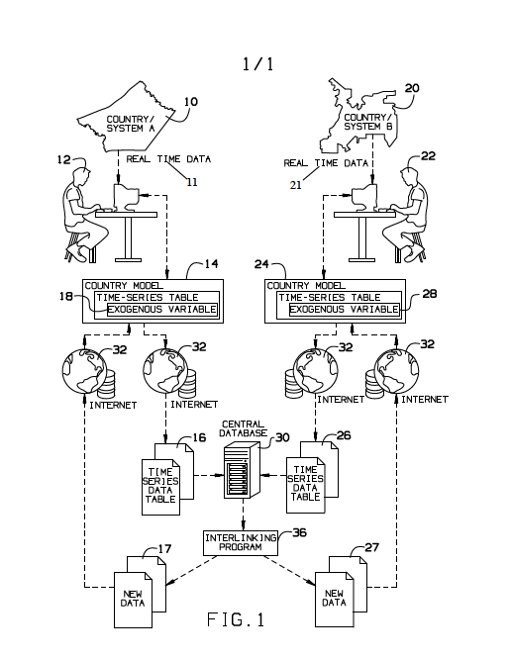
Figure 1: Inter-Linkage Mechanism For Distributed Simulation Models With Human Intervention
(US Patent Pending #61/764,843) <http://tinyurl.com/d4oj9py>
Intellectual Merit: The most significant contribution of this project is its transformational use of stakeholder-crafted models for developing sustainable development strategies, leveraging an unprecedented critical mass of global expertise for national level problem-solving. The multi-disciplinary multi-institutional project team consists of academics and researchers with substantial experience in using modeling and simulation for development objectives, supported by the Millennium Institute and the ECOWAS. The development of a global network of federated and standardized systems models of national sustainable development that can collect and share data on complex energy, healthcare, food security and natural resource management problems is a unique and unprecedented effort that could transform the effectiveness of development efforts and foster global collaboration in solving “wicked” problems collectively.
GEWS represents substantial paradigm shifts, including: (1) The combined use of qualitative (normative) gaming and quantitative (model-based) simulation based on facts and figures rather than exclusively upon insights, habits or traditions, transforming adversaries into collaborators for confrontation prone problems in globally education and training; (2) The development of global “virtual” supercomputer capacity with globally distributed simulation models, which would become a single global model linked through Internet; (3) A hands-on experiential learning apparatus (i.e., simulator/trainer) for government bureaucrats and future leaders for their capacity building on policy analysis, evaluation, with hands-on experiential learning in global collaborative fashion, thus increasing comradeship.
Broader Impacts: This initiative is unique in that it integrates advances in understanding complex development problems through modeling and simulation with training and educating young decision-makers from developing nations in systems thinking for sustainable development. Given its developing country focus and gender empowerment objective, the initiative will both engage and serve underrepresented population groups and potentially enhance broader societal welfare within the target countries. It also creates an infrastructure for building an unprecedented global network of academics, decision-makers and practitioners who can share knowledge, expertise and data as well as the cyber-infrastructure necessary to allow large-scale education and training of students and citizens across the globe in sustainable development strategies through gaming and simulation.
African colleagues will form teams on many subjects planning for 5-year periods, which plans will be submitted for Japanese ODA fund. The GEWS will be suited for fostering camaraderie around the globe, leading to the next stage of human development as fostering global collaborative creativity.
The GLOBAL UNIVERSITY SYSTEM (GUS) (a UNESCO program initiated with funds from the World Bank and the NSF) is a companion global alliance of major universities that will support GEWS in finding, collecting, model building, and processing data. The GUS in participating countries will also provide intercultural and peacekeeping courses in addition to community development. The GUS brings technology to the agenda of global education as launching a trans-cultural, global-wide initiative (using modern techniques of communication) to promote the kinds of global education that will advance peace, justice, understanding, and human wisdom.
COLLABORATION: The GEWS projects cooperate with the GLORIAD and “Africa Coast to Europe (ACE)” ultra high-speed optical fiber submarine cable along the west coast of Africa of Baharicom Development Company. GUS in participating countries will develop simulation models with the guidance from the Millennium Institute, a world-renowned think tank specialized on system dynamic modeling. Those models will be interlinked through ACE/GLORIAD with the guidance from the GLOSAS/USA.
COLLABORATORS: Baharicom Development Co., Ltd.; Global Ring Network for Advanced Applications Development (GLORIAD); GLObal Systems Analysis and Simulation Association in the U.S.A. (GLOSAS/USA); Columbia University/School of International and Public Affairs (SIPA); Millennium Institute; Polytechnic Institute of New York University; Stevens Institute of Technology. Schools participating in GEWS/GUS are numerous.

*******************************************************************************
Takeshi Utsumi, Ph.D., P.E., Chairman
GLObal Systems Analysis and Simulation Association in the U.S.A. (GLOSAS/USA)
Laureate of Lord Perry Award for Excellence in Distance Education
Founder and V.P. for Technology and Coordination of Global University System (GUS)
43-23 Colden Street, #9L, Flushing, NY 11355-5913, U.S.A.
Tel: 718-939-0928; Cel: 646-589-1730; Skype: utsumi
Email: takutsumi0@gmail.com, Web: http://www.friends-partners.org/GLOSAS/
U.S./IRS Employer ID: 11-2999676 <http://tinyurl.com/534gxc>
New York State Tax Exempt ID: 217837 <http://tinyurl.com/47wqbo>
Google Profiles <https://profiles.google.com/takutsumi0/about>
Facebook <http://www.facebook.com/GlobalEarlyWarningSystemsgews>
List Distribution <http://tinyurl.com/2fzx23e>
*******************************************************************************

